(1) Blinking LED:

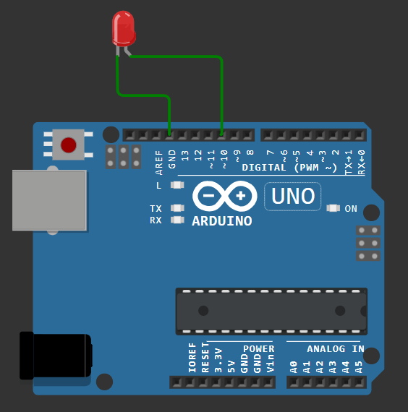

const int ledPin=10;

void setup() {

  // put your setup code here, to run once:

  pinMode(ledPin, OUTPUT);

}

void loop() {

  // put your main code here, to run repeatedly:

  digitalWrite(ledPin, HIGH);

  delay(1000);

  digitalWrite(ledPin, LOW);

  delay(1000);

}

(2.1) Traffic Light (LCD Normal):

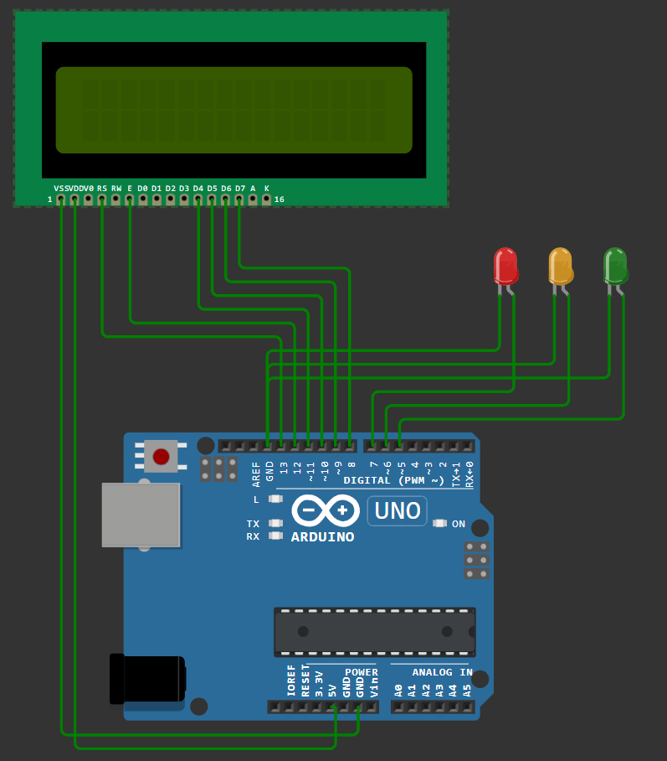

#include <LiquidCrystal.h>

LiquidCrystal lcd(13,12,11,10,9,8);

const int green = 5;

const int orange = 6;

const int red = 7;

void setup() {

  // put your setup code here, to run once:

  lcd.begin(16, 2);

  pinMode(green, OUTPUT);

  pinMode(orange, OUTPUT);

  pinMode(red, OUTPUT);

}

void loop() {

  // put your main code here, to run repeatedly:

  digitalWrite(green,HIGH);

  lcd.setCursor(7,0);

  lcd.print("GO");

  delay(3000);

  digitalWrite(green, LOW);

  lcd.clear();

  digitalWrite(orange, HIGH);

  lcd.setCursor(4,0);

  lcd.print("READY TO");

  lcd.setCursor(4,1);

  lcd.print("STOP");

  delay(100);

  digitalWrite(orange, LOW);

  delay(100);

  digitalWrite(orange, HIGH);

  delay(100);

  digitalWrite(orange, LOW);

  delay(100);

  digitalWrite(orange, HIGH);

  delay(100);

  digitalWrite(orange, LOW);

  delay(100);

  digitalWrite(orange, HIGH);

  delay(300);

  digitalWrite(orange, LOW);

  delay(100);

  digitalWrite(orange, HIGH);

  delay(300);

  digitalWrite(orange, LOW);

  lcd.clear();

  digitalWrite(red, HIGH);

  lcd.setCursor(4,0);

  lcd.print("STOP");

  delay(7000);

  digitalWrite(red, LOW);

  lcd.clear();

  digitalWrite(orange, HIGH);

  lcd.setCursor(4,0);

  lcd.print("READY TO");

  lcd.setCursor(4,1);

  lcd.print("START");

  delay(100);

  digitalWrite(orange, LOW);

  delay(100);

  digitalWrite(orange, HIGH);

  delay(100);

  digitalWrite(orange, LOW);

  delay(100);

  digitalWrite(orange, HIGH);

  delay(100);

  digitalWrite(orange, LOW);

  delay(100);

  digitalWrite(orange, HIGH);

  delay(300);

  digitalWrite(orange, LOW);

  delay(100);

  digitalWrite(orange, HIGH);

  delay(300);

  digitalWrite(orange, LOW);

  lcd.clear();

}

(2.2) Traffic Light (LCD I2C):

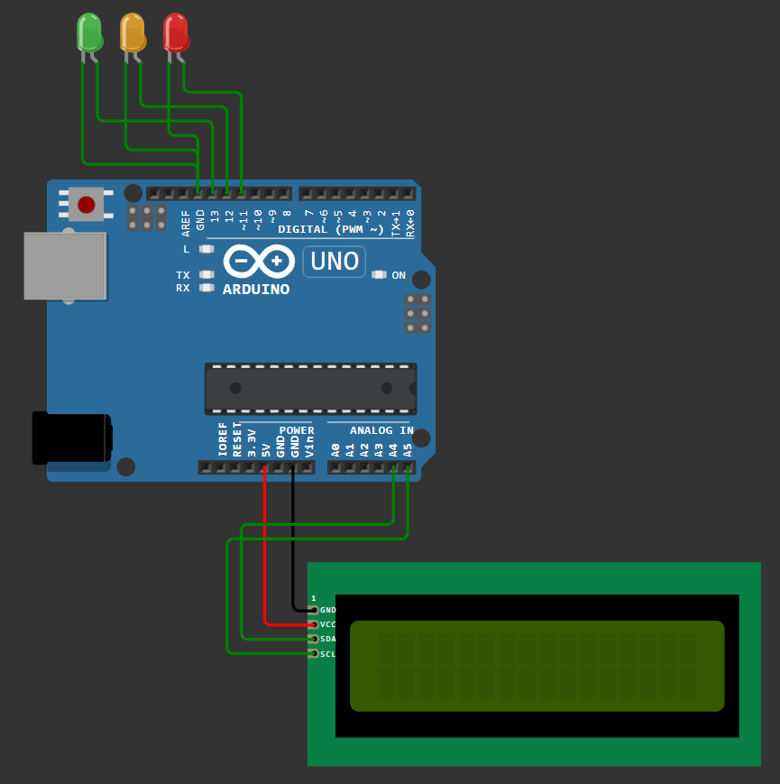

#include <LiquidCrystal_I2C.h>

LiquidCrystal_I2C lcd(0x27, 16, 2);

const int green = 13;

const int orange = 12;

const int red = 11;

void setup() {

  // put your setup code here, to run once:

  lcd.init();

  lcd.backlight();

  pinMode(green, OUTPUT);

  pinMode(orange, OUTPUT);

  pinMode(red, OUTPUT);

}

void loop() {

  // put your main code here, to run repeatedly:

  digitalWrite(green,HIGH);

  lcd.setCursor(7,0);

  lcd.print("GO");

  delay(3000);

  digitalWrite(green, LOW);

  lcd.clear();

  digitalWrite(orange, HIGH);

  lcd.setCursor(4,0);

  lcd.print("READY TO");

  lcd.setCursor(4,1);

  lcd.print("STOP");

  delay(100);

  digitalWrite(orange, LOW);

  delay(100);

  digitalWrite(orange, HIGH);

  delay(100);

  digitalWrite(orange, LOW);

  delay(100);

  digitalWrite(orange, HIGH);

  delay(100);

  digitalWrite(orange, LOW);

  delay(100);

  digitalWrite(orange, HIGH);

  delay(300);

  digitalWrite(orange, LOW);

  delay(100);

  digitalWrite(orange, HIGH);

  delay(300);

  digitalWrite(orange, LOW);

  lcd.clear();

  digitalWrite(red, HIGH);

  lcd.setCursor(4,0);

  lcd.print("STOP");

  delay(7000);

  digitalWrite(red, LOW);

  lcd.clear();

  digitalWrite(orange, HIGH);

  lcd.setCursor(4,0);

  lcd.print("READY TO");

  lcd.setCursor(4,1);

  lcd.print("START");

  delay(100);

  digitalWrite(orange, LOW);

  delay(100);

  digitalWrite(orange, HIGH);

  delay(100);

  digitalWrite(orange, LOW);

  delay(100);

  digitalWrite(orange, HIGH);

  delay(100);

  digitalWrite(orange, LOW);

  delay(100);

  digitalWrite(orange, HIGH);

  delay(300);

  digitalWrite(orange, LOW);

  delay(100);

  digitalWrite(orange, HIGH);

  delay(300);

  digitalWrite(orange, LOW);

  lcd.clear();

}

(3.1) Ultrasonic Sensor (8 LED's):

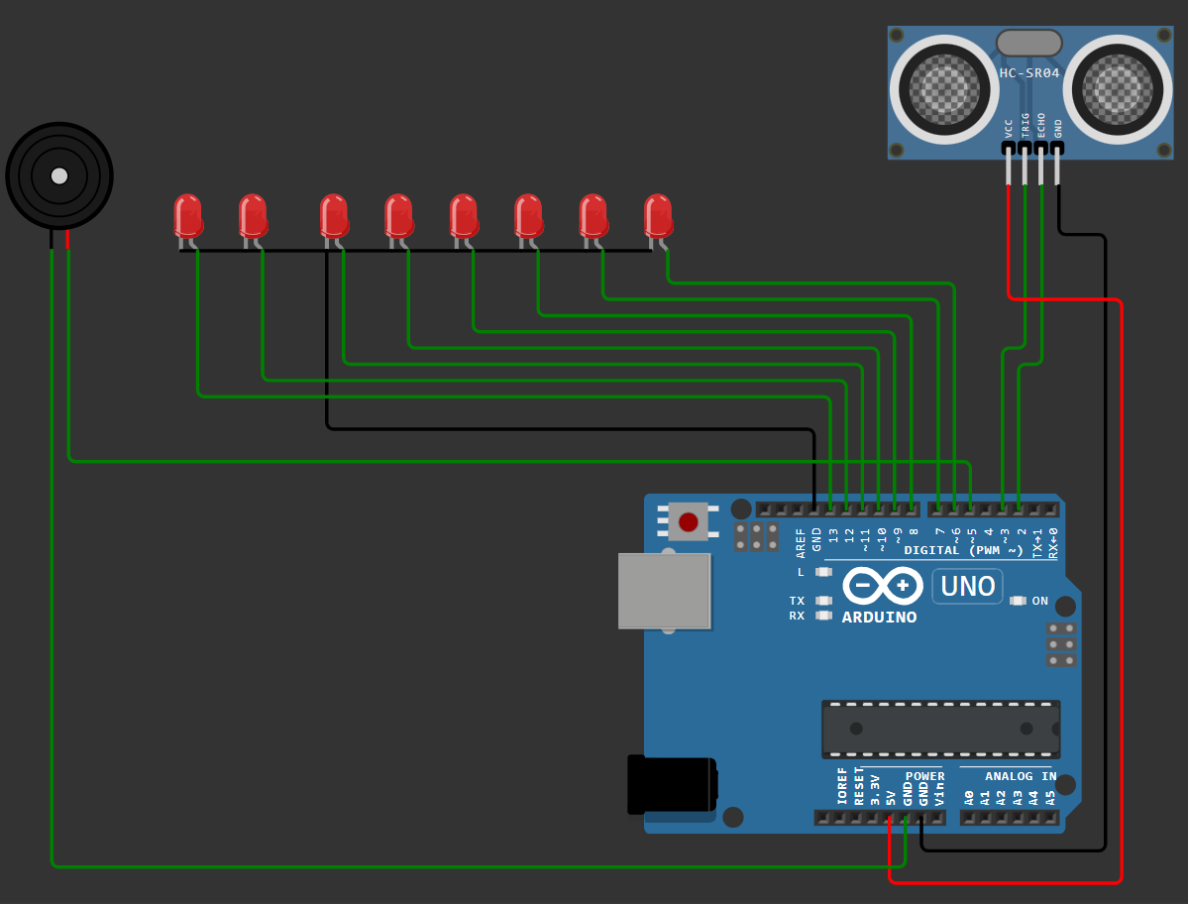

#define ECHO_PIN 2

#define TRIG_PIN 3

int LED_PIN1= 6;

int LED_PIN2= 7;

int LED_PIN3= 8;

int LED_PIN4= 9;

int LED_PIN5= 10;

int LED_PIN6= 11;

int LED_PIN7= 12;

int LED_PIN8= 13;

float buzzer= 5;

void setup() {

**Serial**.begin(115200);

  pinMode(TRIG_PIN, OUTPUT);

  pinMode(ECHO_PIN, INPUT);

  pinMode(LED_PIN1, OUTPUT);

  pinMode(LED_PIN2, OUTPUT);

  pinMode(LED_PIN3, OUTPUT);

  pinMode(LED_PIN4, OUTPUT);

  pinMode(LED_PIN5, OUTPUT);

  pinMode(LED_PIN6, OUTPUT);

  pinMode(LED_PIN7, OUTPUT);

  pinMode(LED_PIN8, OUTPUT);

  pinMode(buzzer, OUTPUT);

}

int readDistanceCM() {

  digitalWrite(TRIG_PIN, LOW);

  delayMicroseconds(2);

  digitalWrite(TRIG_PIN, HIGH);

  delayMicroseconds(10);

  digitalWrite(TRIG_PIN, LOW);

  int duration = pulseIn(ECHO_PIN, HIGH);

  return round(duration * 0.0342 / 2);

}

void loop() {

  digitalWrite(buzzer, LOW);

  int distance = readDistanceCM();

**Serial**.print("Measured distance: ");

  boolean d1= distance>0;

  boolean d2= distance>50;

  boolean d3= distance>100;

  boolean d4= distance>150;

  boolean d5= distance>200;

  boolean d6= distance>250;

  boolean d7=distance>300;

  boolean d8=distance>350 && distance<=400;

  boolean buzz =  distance<50;

**Serial**.println(distance);

  digitalWrite(buzzer, buzz);

  digitalWrite(LED_PIN1, d1);

  digitalWrite(LED_PIN2, d2);

  digitalWrite(LED_PIN3, d3);

  digitalWrite(LED_PIN4, d4);

  digitalWrite(LED_PIN5, d5);

  digitalWrite(LED_PIN6, d6);

  digitalWrite(LED_PIN7,d7);

  digitalWrite(LED_PIN8,d8);

  delay(100);

}

(3.2) Ultrasonic Sensor:

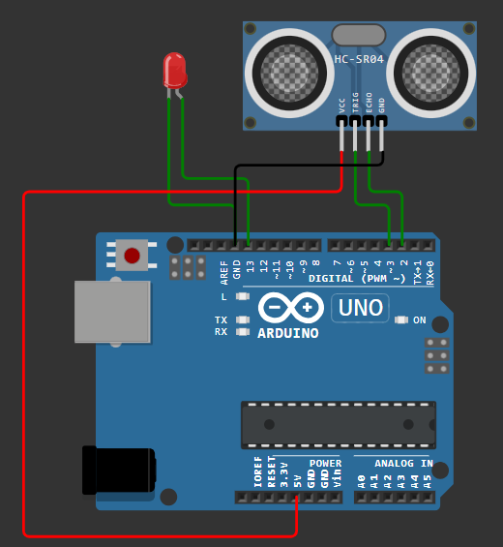

#define ECHO_PIN 2

#define TRIG_PIN 3

void setup() {

**Serial**.begin(115200);

  pinMode(LED_BUILTIN, OUTPUT);

  pinMode(TRIG_PIN, OUTPUT);

  pinMode(ECHO_PIN, INPUT);

}

float readDistanceCM() {

  digitalWrite(TRIG_PIN, LOW);

  delayMicroseconds(2);

  digitalWrite(TRIG_PIN, HIGH);

  delayMicroseconds(10);

  digitalWrite(TRIG_PIN, LOW);

  int duration = pulseIn(ECHO_PIN, HIGH);  // Fixed typo: pulseln to pulseIn

  return duration * 0.034 / 2;

}

void loop() {

  float distance = readDistanceCM();

  bool isNearby = distance < 100;

  digitalWrite(LED_BUILTIN, isNearby);

**Serial**.print("Measured distance: ");

**Serial**.println(distance);  // Changed to print 'distance' variable

  delay(100);

}

(4.1) Continuous Increment:

**(i) Anode**

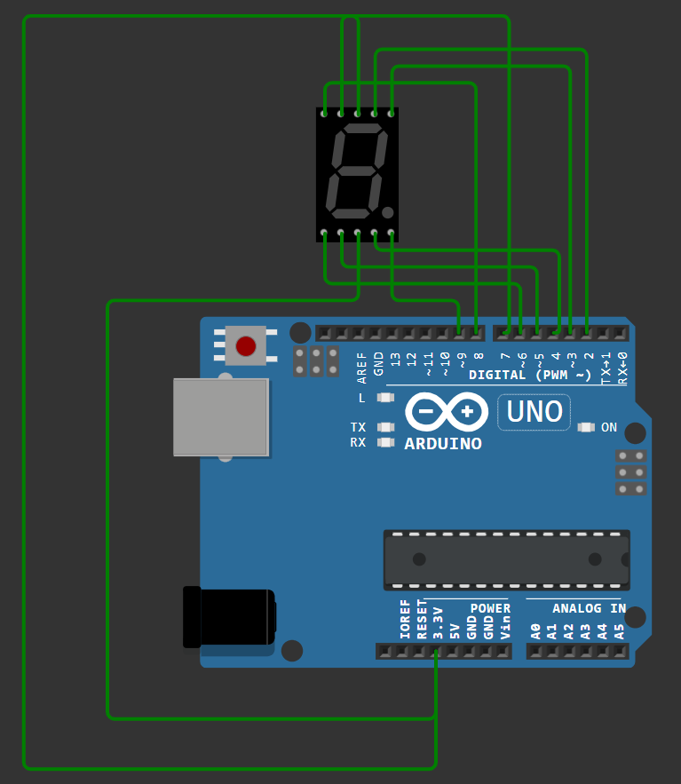

int a = 2;

int b = 3;

int c = 4;

int d = 5;

int e = 6;

int f = 7;

int g = 8;

int point = 9;

void setup()

{

  pinMode(a, OUTPUT); //a

  pinMode(b, OUTPUT); //b

  pinMode(c, OUTPUT); //c

  pinMode(d, OUTPUT); //d

  pinMode(e, OUTPUT); //e

  pinMode(f, OUTPUT); //f

  pinMode(g, OUTPUT); //g

  pinMode(point, OUTPUT); //point

}

void showNumber(int number)

{

  if(number != 1 && number != 4)

    digitalWrite(a,LOW);

  if(number != 5 && number != 6)

    digitalWrite(b,LOW);

  if(number != 2)

    digitalWrite(c,LOW);

  if(number != 1 && number != 4 && number !=7)

    digitalWrite(d,LOW);

  if(number == 2 || number == 6 || number == 8 || number == 0)

    digitalWrite(e,LOW);

  if(number != 1 && number != 2 && number != 3 && number != 7)

    digitalWrite(f,LOW);

  if (number != 0 && number != 1 && number != 7)

    digitalWrite(g,LOW);

}

void turnOff()

{

  digitalWrite(a,HIGH);

  digitalWrite(b,HIGH);

  digitalWrite(c,HIGH);

  digitalWrite(d,HIGH);

  digitalWrite(e,HIGH);

  digitalWrite(f,HIGH);

  digitalWrite(g,HIGH);

  digitalWrite(point,HIGH);

}

void loop()

{

  for(int i=0;i<10;i++)

  {

    showNumber(i);

    delay(1000);

    turnOff();

  }

}

**(ii) Cathode**

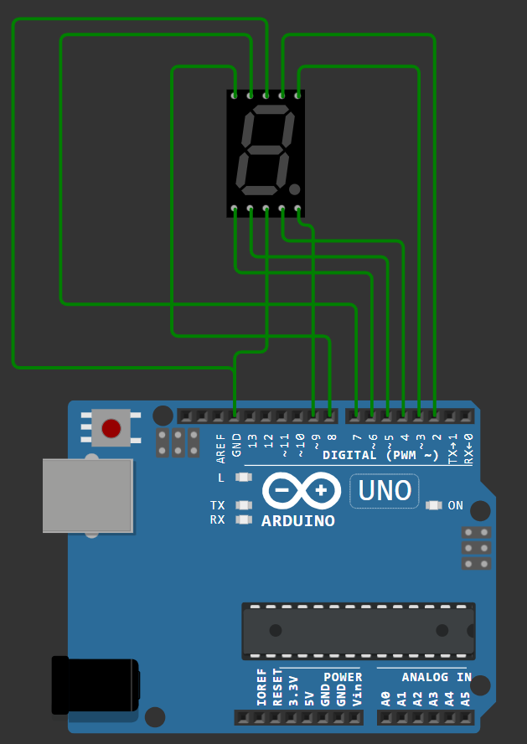

int a = 2;

int b = 3;

int c = 4;

int d = 5;

int e = 6;

int f = 7;

int g = 8;

int point = 9;

void setup()

{

  pinMode(a, OUTPUT); //a

  pinMode(b, OUTPUT); //b

  pinMode(c, OUTPUT); //c

  pinMode(d, OUTPUT); //d

  pinMode(e, OUTPUT); //e

  pinMode(f, OUTPUT); //f

  pinMode(g, OUTPUT); //g

  pinMode(point, OUTPUT); //point

}

void showNumber(int number)

{

  if(number != 1 && number != 4)

    digitalWrite(a,HIGH);

  if(number != 5 && number != 6)

    digitalWrite(b,HIGH);

  if(number != 2)

    digitalWrite(c,HIGH);

  if(number != 1 && number != 4 && number != 7)

    digitalWrite(d,HIGH);

  if(number == 2 || number == 6 || number == 8 || number == 0)

    digitalWrite(e,HIGH);

  if(number != 1 && number != 2 && number != 3 && number != 7)

    digitalWrite(f,HIGH);

  if (number != 0 && number != 1 && number != 7)

    digitalWrite(g,HIGH);

}

void turnOff()

{

  digitalWrite(a,LOW);

  digitalWrite(b,LOW);

  digitalWrite(c,LOW);

  digitalWrite(d,LOW);

  digitalWrite(e,LOW);

  digitalWrite(f,LOW);

  digitalWrite(g,LOW);

  digitalWrite(point,LOW);

}

void loop()

{

  for(int i=0;i<10;i++)

  {

    showNumber(i);

    delay(1000);

    turnOff();

  }

}

(4.2) Increment with Push button:

**(i) Anode**

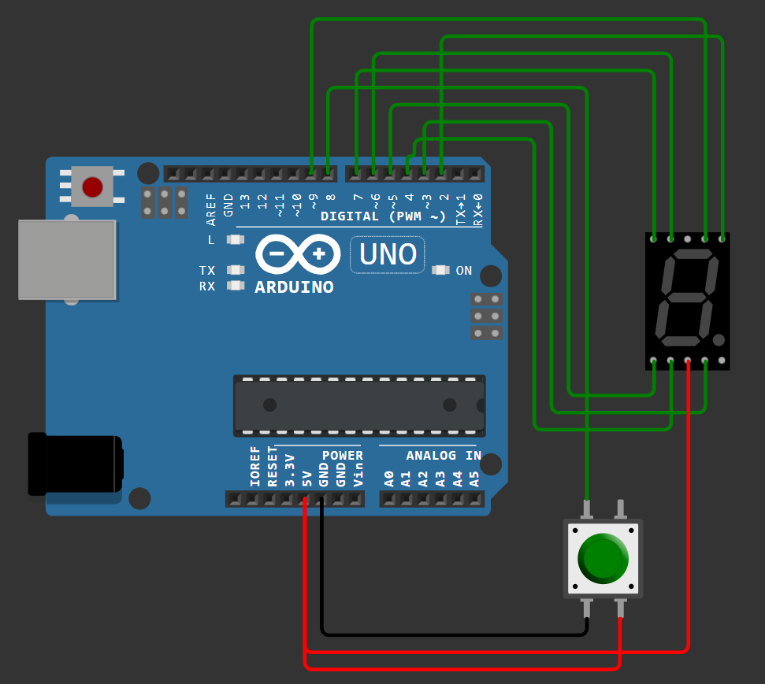

int A = 9;

int B = 2;

int C = 3;

int D = 4;

int E = 5;

int F = 6;

int G = 7;

int switchUpPin = 8;

int counter = 0;

int buttonUpState = 0;

int lastButtonUpState = 0;

void setup() {

Serial.begin(9600);

pinMode(A, OUTPUT);

pinMode(B, OUTPUT);

pinMode(C, OUTPUT);

pinMode(D, OUTPUT);

pinMode(E, OUTPUT);

pinMode(F, OUTPUT);

pinMode(G, OUTPUT);

pinMode(switchUpPin, INPUT);

}

void loop() {

buttonUpState = digitalRead(switchUpPin);

if (buttonUpState != lastButtonUpState) {

if (buttonUpState == HIGH) {

counter = (counter + 1) % 10; // Increment and wrap to 0 after 9

showNumber(counter);

delay(300); // Debounce delay

}

lastButtonUpState = buttonUpState;

}

delay(50); // Small delay to prevent bouncing

}

void showNumber(int number) {

// Turn off all segments before setting the new number (HIGH for anode)

digitalWrite(A, HIGH);

digitalWrite(B, HIGH);

digitalWrite(C, HIGH);

digitalWrite(D, HIGH);

digitalWrite(E, HIGH);

digitalWrite(F, HIGH);

digitalWrite(G, HIGH);

// Set segments according to the number (LOW to turn on in anode configuration)

if (number != 1 && number != 4)

digitalWrite(A, LOW);

if (number != 5 && number != 6)

digitalWrite(B, LOW);

if (number != 2)

digitalWrite(C, LOW);

if (number != 1 && number != 4 && number != 7)

digitalWrite(D, LOW);

if (number == 2 || number == 6 || number == 8 || number == 0)

digitalWrite(E, LOW);

if (number != 1 && number != 2 && number != 3 && number != 7)

digitalWrite(F, LOW);

if (number != 0 && number != 1 && number != 7)

digitalWrite(G, LOW);

}

**(ii) Cathode**

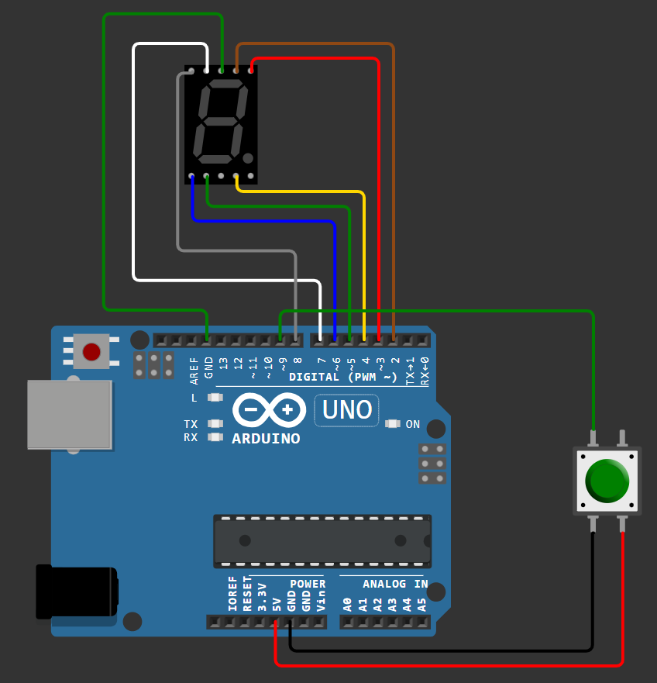

int A = 2;

int B = 3;

int C = 4;

int D = 5;

int E = 6;

int F = 7;

int G = 8;

int switchUpPin = 9;

int counter = 0;

int buttonUpState = 0;

int lastButtonUpState = 0;

void setup() {

**Serial**.begin(9600);

  pinMode(A, OUTPUT);

  pinMode(B, OUTPUT);

  pinMode(C, OUTPUT);

  pinMode(D, OUTPUT);

  pinMode(E, OUTPUT);

  pinMode(F, OUTPUT);

  pinMode(G, OUTPUT);

  pinMode(switchUpPin, INPUT);

}

void loop() {

  buttonUpState = digitalRead(switchUpPin);

  if (buttonUpState != lastButtonUpState) {

    if (buttonUpState == HIGH) {

      counter = (counter + 1) % 10; // Increment and wrap to 0 after 9

      showNumber(counter);

      delay(300); // Debounce delay

    }

    lastButtonUpState = buttonUpState;

  }

  delay(50); // Small delay to prevent bouncing

}

void showNumber(int number) {

  // Turn off all segments before setting the new number

  digitalWrite(A, LOW);

  digitalWrite(B, LOW);

  digitalWrite(C, LOW);

  digitalWrite(D, LOW);

  digitalWrite(E, LOW);

  digitalWrite(F, LOW);

  digitalWrite(G, LOW);

  // Set segments according to the number

  if (number != 1 && number != 4)

    digitalWrite(A, HIGH);

  if (number != 5 && number != 6)

    digitalWrite(B, HIGH);

  if (number != 2)

    digitalWrite(C, HIGH);

  if (number != 1 && number != 4 && number != 7)

    digitalWrite(D, HIGH);

  if (number == 2 || number == 6 || number == 8 || number == 0)

    digitalWrite(E, HIGH);

  if (number != 1 && number != 2 && number != 3 && number != 7)

    digitalWrite(F, HIGH);

  if (number != 0 && number != 1 && number != 7)

    digitalWrite(G, HIGH);

}

(5.1) Servo with Potentiometer:

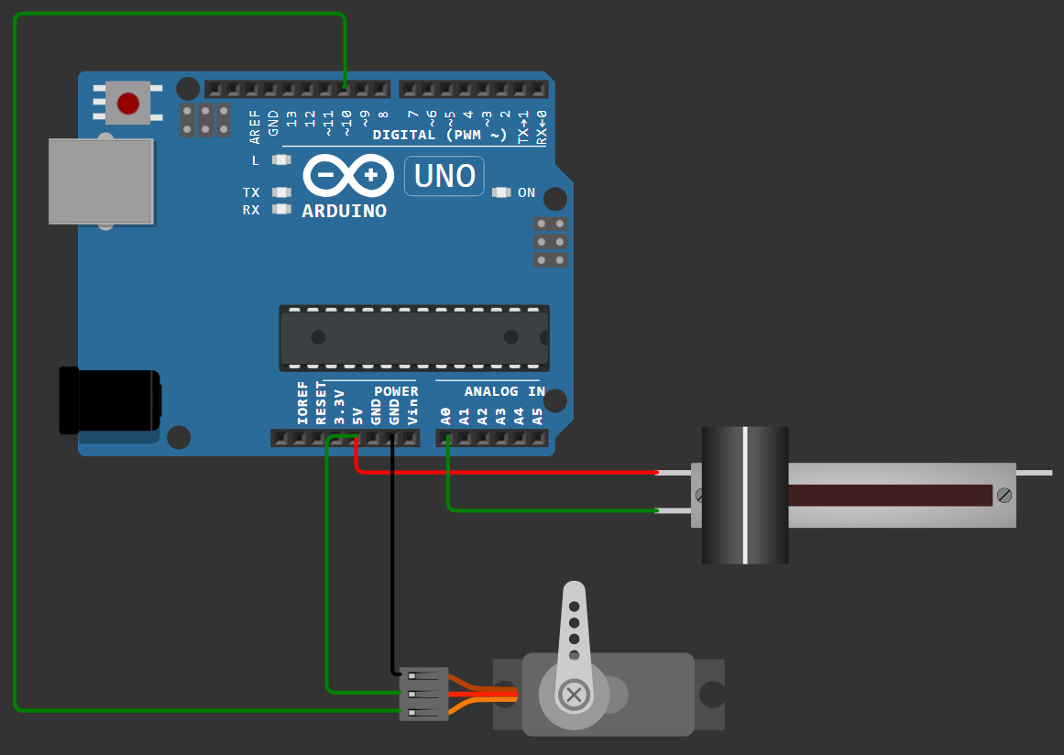

#include <Servo.h>

Servo myservo;

const int servo=10,

potentiometer=A0;

int pos=0;

void setup() {

  myservo.attach(servo);

  myservo.write(pos);

}

void loop() {

  int value=analogRead(potentiometer);

  pos=map(value,0,1023,0,180);

  myservo.write(pos);

  delay(20);

}

(5.2) Servo To and Fro:

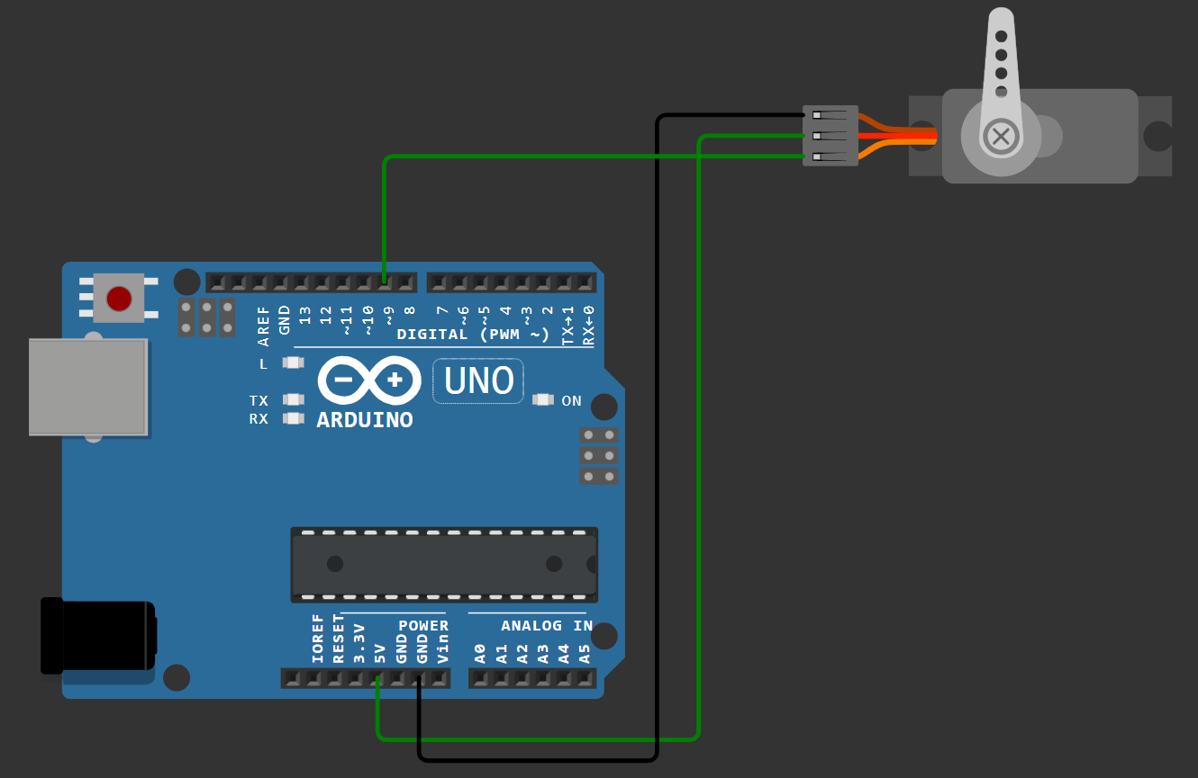

#include<Servo.h>

Servo myservo;

void setup() {

  myservo.attach(9);

  myservo.write(0);

}

void loop() {

  for(int i=0; i <= 180; i++){

    myservo.write(i);

    delay(15);

  }

  for(int j=180;j>=0;j -- ){

    myservo.write(j);

    delay(15);

  }

}

(5.3) Servo Full Rotation:

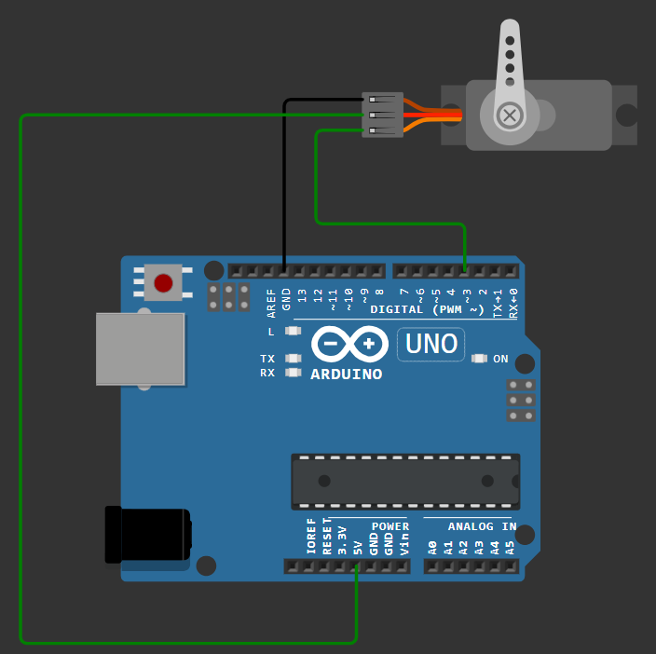

#include <Servo.h>

Servo myservo;

void setup() {

  myservo.attach(3);  // Attach the servo on pin 3

}

void loop() {

  myservo.write(0);

  delay(2000);

  myservo.write(30);

  delay(2000);

  myservo.write(60);

  delay(2000);

  myservo.write(90);

  delay(2000);

  myservo.write(120);

  delay(2000);

  myservo.write(150);

  delay(2000);

  myservo.write(180);

  delay(2000);

  myservo.write(150);

  delay(2000);

  myservo.write(120);

  delay(2000);

  myservo.write(90);

  delay(2000);

  myservo.write(60);

  delay(2000);

  myservo.write(30);

  delay(2000);

  myservo.write(0);

  delay(2000);

}

(6.1) PIR (LCD Normal):

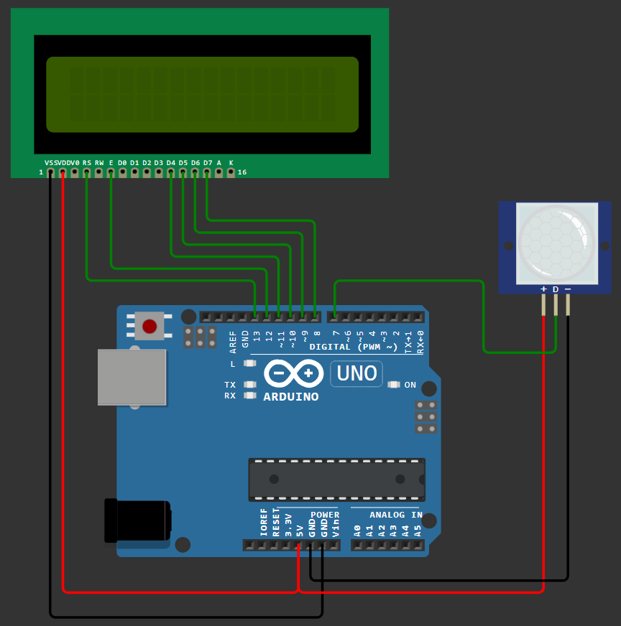

#include <LiquidCrystal.h>

LiquidCrystal lcd(13,12,11,10,9,8);

int pir = 7;

int state = LOW;

int val = 0;

void setup() {

  pinMode(pir, INPUT);

**Serial**.begin(9600);

  lcd.begin(16, 2);

}

void loop(){

  val = digitalRead(pir);

  if (val == HIGH) {

    delay(100);

    if (state == LOW) {

      lcd.clear();

      lcd.setCursor(0,0);

      lcd.print("Movement");

      lcd.setCursor(0,1);

      lcd.print("Detected!");

      state = HIGH;

    }

  }

  else{

    lcd.setCursor(0,0);

    lcd.print("No");

    lcd.setCursor(0,1);

    lcd.print("Movement");

    delay(200);

    if (state==HIGH){

      lcd.clear();

      lcd.setCursor(0,0);

      lcd.print("No");

      lcd.setCursor(0,1);

      lcd.print("Movement");

      state=LOW;

    }

  }

}

(6.2) PIR (LCD I2C):

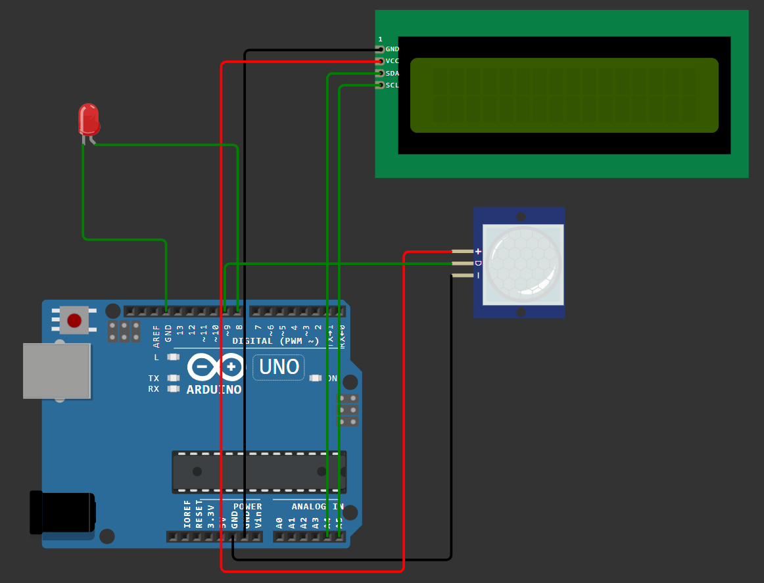

#include <LiquidCrystal_I2C.h>

LiquidCrystal_I2C lcd(0x27, 16, 2);

int led = 8;                // the pin that the LED is atteched to

int sensor = 9;              // the pin that the sensor is atteched to

int state = LOW;             // by default, no motion detected

int val = 0;                 // variable to store the sensor status (value)

void setup() {

   lcd.init(); // Turn on the LCD backlight

   lcd.backlight();

  pinMode(led, OUTPUT);      // initalize LED as an output

  pinMode(sensor, INPUT);    // initialize sensor as an input

**Serial**.begin(9600);        // initialize serial

}

void loop(){

  val = digitalRead(sensor);   // read sensor value

  if (val == HIGH) {           // check if the sensor is HIGH

    digitalWrite(led, HIGH);   // turn LED ON

    delay(100);                // delay 100 milliseconds

    if (state == LOW) {

      lcd.clear();

**Serial**.println("Motion detected!");

      lcd.print("Motion detected");

      state = HIGH;             // update variable state to HIGH

    }

  }

  else {

      digitalWrite(led, LOW); // turn LED OFF

      delay(200);             // delay 200 milliseconds

      if (state == HIGH){

        lcd.clear();

**Serial**.println("Motion stopped!");

        lcd.print("Motion stopped");

        state = LOW;       // update variable state to LOW

    }

  }

}

(6.3) PIR without LCD:

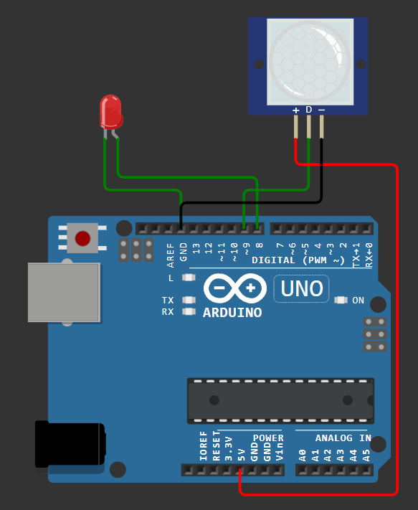

int led = 8;

int pir = 9;

int state = LOW;

int val = 0;

void setup() {

  pinMode(led, OUTPUT);

  pinMode(pir, INPUT);

**Serial**.begin(9600);

}

void loop() {

  val = digitalRead(pir);

  if (val == HIGH) {

    digitalWrite(led, HIGH);

    delay(100);

    if (state == LOW) {

**Serial**.println("Movement detected!");

      state = HIGH;

    }

  } else {

    digitalWrite(led, LOW);

    delay(200);

    if (state == HIGH) {

**Serial**.println("No movement!");

      state = LOW;

    }

  }

}